SIMATS ENGINEERING

ASSESSMENT TOOL 2: Concept Mapping

COURSE NAME: Cloud Computing and
Big Data Analytics
COURSE CODE: CSA15

COURSE OUTCOME COVERED
CO1: Apply cloud computing technologies including hardware-software evolution, virtualization, web services, and service models to develop cloud-based solutions. (BL2)
Assessment Tool Weightage: 20%

Dave's Taxonomy: Imitation (Level 1) Question Count: 4

Total Marks: 20

Code of Conduct
I ASWATHA V- 192525390 certify that this submission is my original work and that I have adhered to the guidelines specified for this assessment.
I understand that any violation of academic integrity rules will result in disciplinary action.

Signature of the student:

Assessment Tasks Concept Mapping Tasks
Create concept maps for the following tasks. Each map must show key nodes, link labels, and a logical hierarchy.
- Concept Map 1: Cloud Computing Fundamentals. Include definition, characteristics, benefits, and limitations.

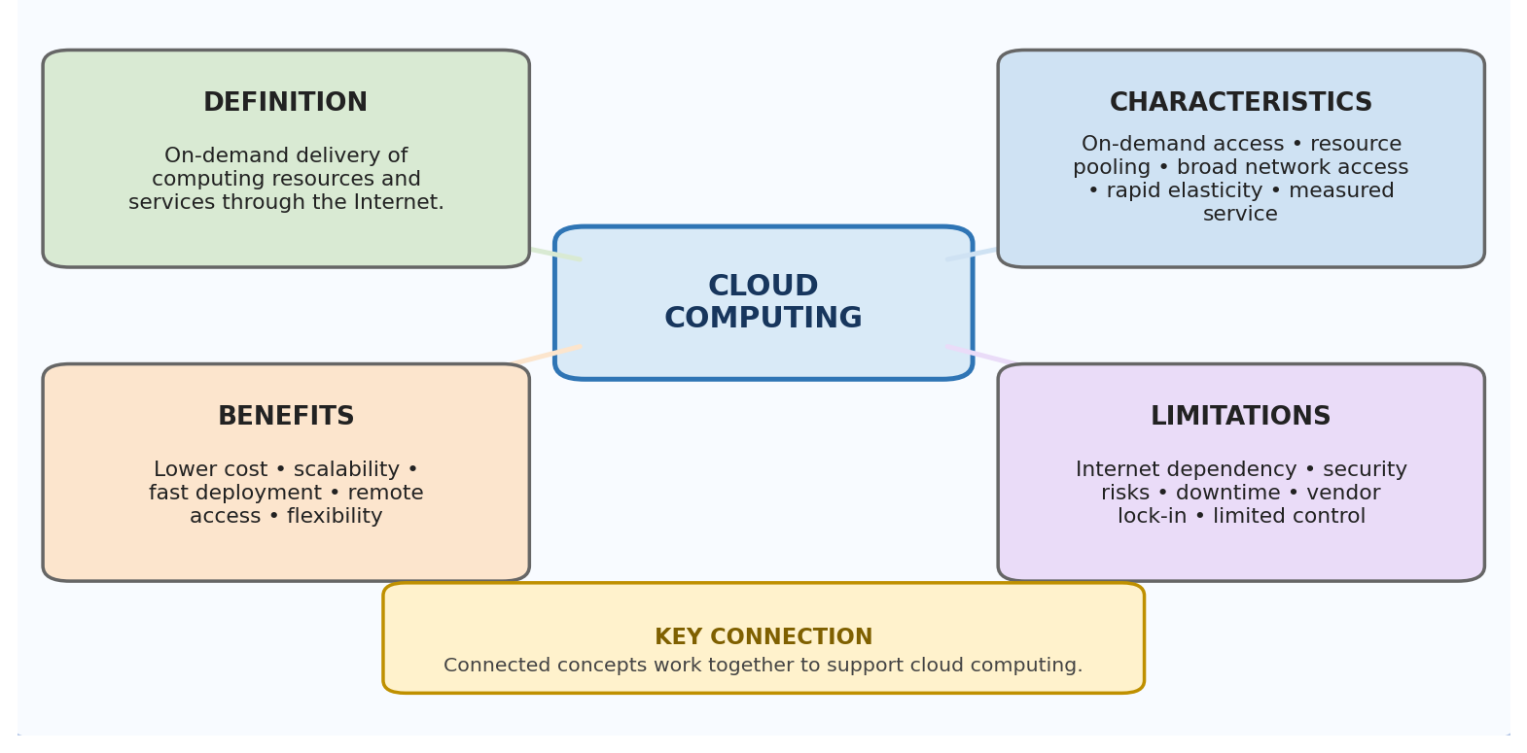

Introduction
Cloud computing is a modern technology that provides computing resources through the Internet. Instead of storing data and running applications only on a personal computer, users can access servers, storage, software, databases, and other resources from cloud platforms.

Definition of Cloud Computing
Cloud computing means delivering computing services over the Internet whenever they are required. Users can access these services without purchasing and maintaining all the physical hardware themselves. Cloud providers manage the infrastructure and provide resources according to the user's needs.

Characteristics of Cloud Computing
Cloud computing has several important characteristics that make it different from traditional computing. Users can obtain resources whenever required through on-demand self-service. Cloud services can also be accessed from different devices and locations using the Internet.
Another important characteristic is resource pooling. Cloud providers use a common pool of servers, storage, and networking resources for multiple users. Resources can be allocated and released depending on demand.
Cloud computing also provides rapid elasticity. This means resources can be increased when the workload becomes high and reduced when the workload becomes low. The usage of resources can also be measured, allowing users and providers to monitor consumption.

Benefits of Cloud Computing
One major benefit of cloud computing is cost reduction. Organizations do not need to purchase large amounts of physical hardware before starting a project. They can use cloud resources and pay according to their requirements.
Cloud computing also provides scalability and flexibility. A business can increase its computing resources when the number of users increases and reduce them when the demand decreases. This helps organizations avoid unnecessary infrastructure costs.
Another important benefit is easy accessibility. Cloud applications and data can be accessed from different locations using an Internet connection. This supports remote work, online learning, collaboration, and digital services.

Limitations of Cloud Computing
Cloud computing also has some limitations. Most cloud services depend on a stable Internet connection. If the network connection is unavailable, users may not be able to access their applications or data.
Security and privacy are also important concerns because data is stored on infrastructure managed by external providers. Organizations must use proper security methods to protect sensitive information.
Cloud services may also experience downtime because of technical failures or maintenance. In addition, moving applications and data from one provider to another can sometimes be difficult because of vendor dependency.

Conclusion
Cloud computing provides flexible and scalable computing resources through the Internet. Its characteristics such as on-demand access, resource pooling, elasticity, and measured usage make it useful for modern applications. Although it has limitations related to security, Internet dependency, and service availability, cloud computing has become an important part of modern digital infrastructure.

- Concept Map 2: Evolution of Cloud Computing. Connect hardware evolution, internet software evolution, distributed systems, and service delivery.
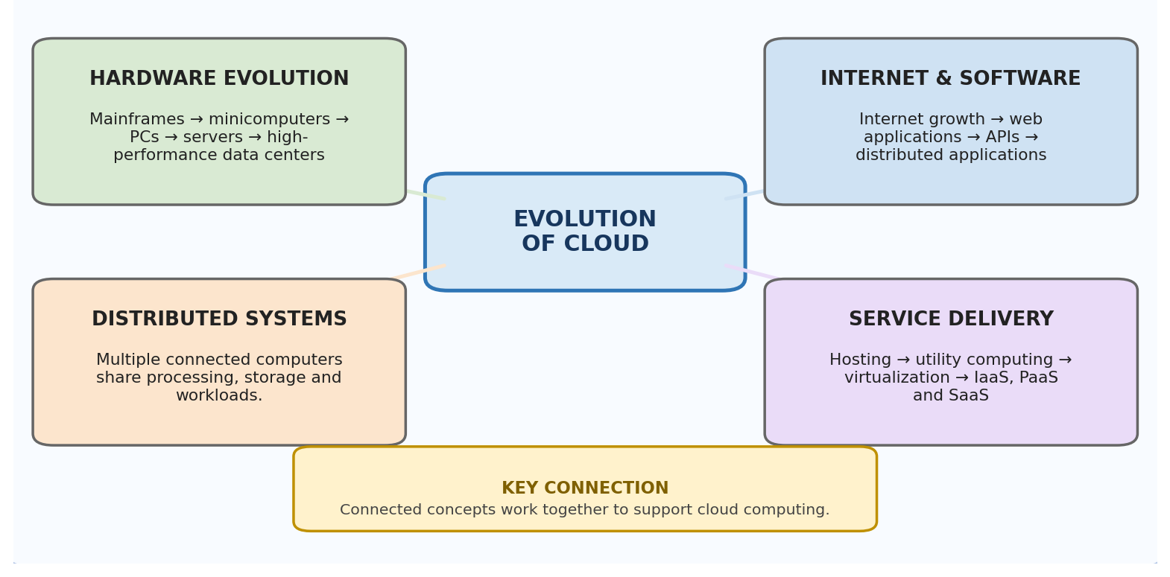

Introduction
Cloud computing developed gradually through improvements in computer hardware, networking, software, distributed systems, and Internet technologies. The modern cloud is the result of combining these technologies to provide computing resources as services.

Hardware Evolution
Early computing systems mainly used large mainframe computers. These systems were expensive and required special environments and trained professionals. Computing was mainly centralized, and users depended on the central machine for processing.
Later, minicomputers and personal computers became available. Computers became smaller, more affordable, and accessible to more users. This increased the use of computing in homes, educational institutions, and businesses.
The development of powerful servers and large data centers was another important step. Organizations started using groups of servers to store data and run applications. These data centers later became the physical foundation for cloud computing.

Internet and Software Evolution
The growth of the Internet allowed computers located in different places to communicate with each other. Websites and web applications made it possible for users to access information and services remotely.
As web technologies developed, applications became more interactive and useful. Online communication, collaboration, storage, and software services became common. APIs also allowed different applications to communicate and exchange information.

Distributed Systems
Distributed computing introduced the idea of using multiple computers together to perform tasks. Instead of depending on a single computer, workloads could be divided among several connected systems.
This improved performance, reliability, and scalability. Distributed systems became an important foundation for cloud computing because cloud platforms use large numbers of connected servers to provide services.

Virtualization
Virtualization further supported the development of cloud computing. It allowed one physical server to run multiple virtual machines. Each virtual machine could operate as an independent computing environment.
This improved hardware utilization and made resource management easier. Virtualization also allowed cloud providers to create and allocate computing environments quickly.

Service Delivery
Over time, computing changed from locally installed systems to services delivered through networks and the Internet. Cloud providers began offering infrastructure, platforms, and complete software applications as services.
This development resulted in service models such as IaaS, PaaS, and SaaS. Users could now access computing resources without directly managing the physical infrastructure.

Conclusion
The evolution of cloud computing involved many stages. The development of hardware, Internet technologies, distributed systems, virtualization, and online services gradually created the modern cloud environment. Cloud computing can therefore be understood as the result of continuous technological development rather than a single invention.

- Concept Map 3: Service Models. Map IaaS, PaaS, SaaS, and XaaS with provider responsibilities and user responsibilities.
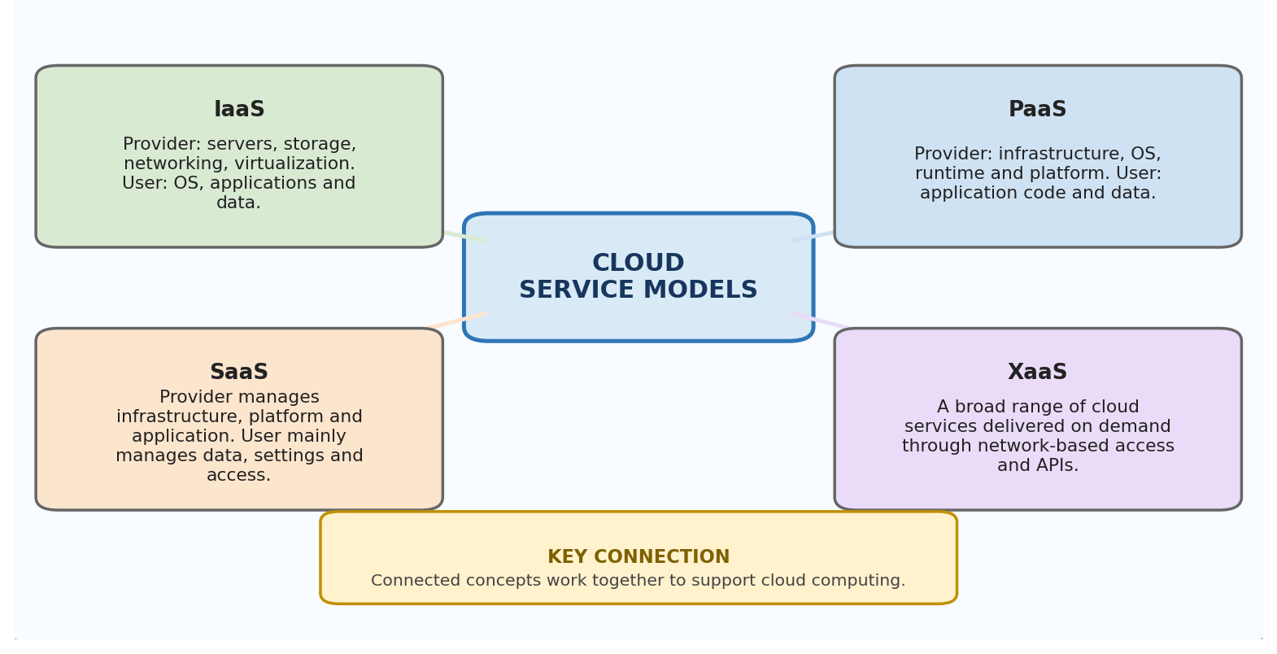

Introduction
Cloud service models explain how computing services are provided to users through the Internet. The main models are IaaS, PaaS, SaaS, and XaaS. Each model provides a different level of control and management between the cloud provider and the user.

Infrastructure as a Service (IaaS)
IaaS provides basic computing infrastructure through the cloud. The provider supplies virtual servers, storage, networking, and other infrastructure resources.
In IaaS, the cloud provider manages the physical hardware and virtualization environment. The user is responsible for managing the operating system, applications, and data. This model provides users with greater control over their computing environment.

Platform as a Service (PaaS)
PaaS provides a ready-made platform for developing and running applications. Developers do not need to manage the underlying servers and operating systems.
The provider manages the infrastructure, operating system, runtime environment, and development platform. The user mainly concentrates on application code and data. This makes application development faster and easier.

Software as a Service (SaaS)
SaaS provides complete software applications through the Internet. Users normally access the application using a web browser or application interface.
The cloud provider manages the infrastructure, platform, software, updates, and maintenance. Users mainly manage their accounts, settings, and data. SaaS is useful because users can use software without installing and maintaining the complete system themselves.

Everything as a Service (XaaS)
XaaS stands for Everything as a Service or Anything as a Service. It represents the wider idea of providing different technology resources as cloud-based services.
Examples include storage services, database services, security services, communication services, and artificial intelligence services. Users can select the services they require instead of building every technology component themselves.

Responsibility in Service Models
The level of user responsibility changes between the service models. IaaS provides more control to the user, while SaaS provides more management responsibility to the provider.
PaaS provides a balance between the two. The provider manages the infrastructure and platform, while the developer focuses on the application. XaaS extends the idea by allowing different types of technology services to be consumed through the cloud.

Conclusion
Cloud service models allow users to select the level of control and management that suits their requirements. IaaS is suitable for infrastructure control, PaaS supports application development, SaaS provides ready-to-use software, and XaaS provides a wide range of specialized services. These models make cloud computing flexible and suitable for different types of users.

- Concept Map 4: Virtualization and Web Services as Enablers of Cloud. Show how these two concepts support cloud deployment and scalability.
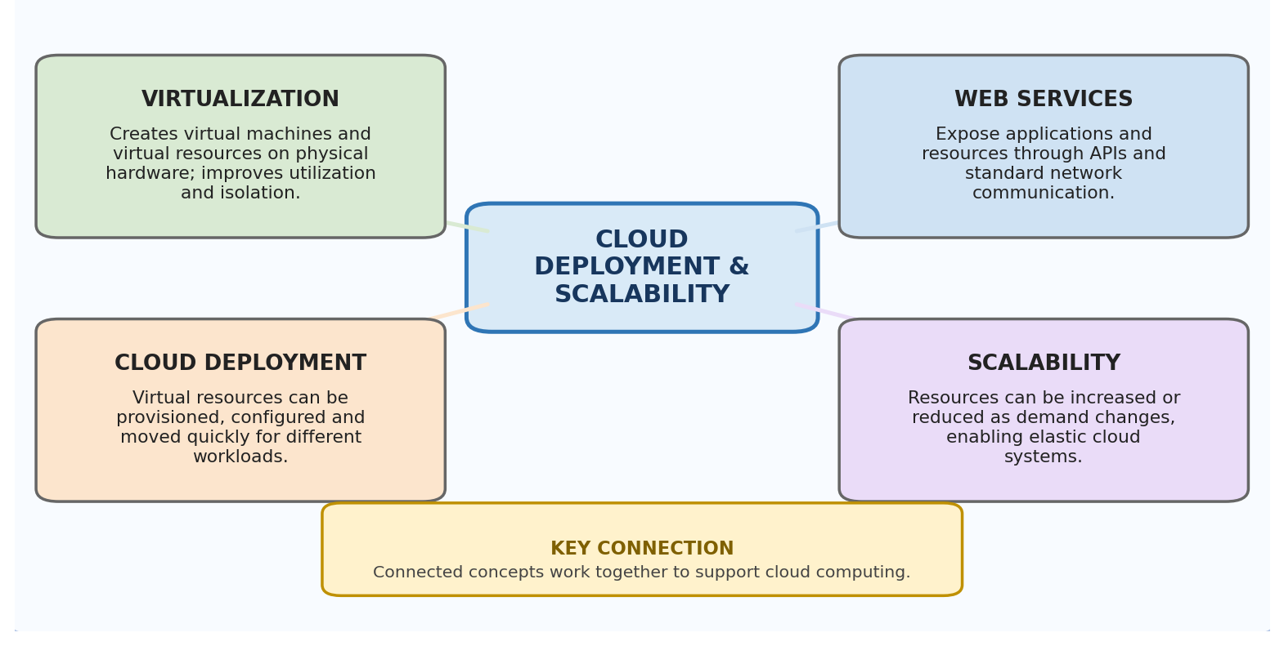

Introduction
Virtualization and web services are two important technologies that support cloud computing. Virtualization helps cloud providers manage physical hardware efficiently, while web services allow applications and users to communicate with cloud resources through networks.

Virtualization
Virtualization is the process of creating virtual versions of computing resources. A single physical server can be divided into multiple virtual machines, and each virtual machine can run its own operating system and applications.
This allows several users or applications to share the same physical hardware. As a result, cloud providers can use their infrastructure more efficiently and reduce unused computing capacity.

Importance of Virtualization
Virtualization makes cloud deployment faster and more flexible. New virtual machines can be created whenever additional resources are required. They can also be removed when they are no longer needed.
Virtual machines can operate independently from each other. This provides isolation between different applications and users. Virtualization also makes it easier to move, copy, or manage computing environments.

Web Services
Web services allow different software applications to communicate over a network. They provide standard methods through which applications can request and exchange information.
Technologies such as REST, APIs, HTTP, JSON, and XML are commonly associated with web-based services. These technologies allow cloud applications to communicate with users and other applications.

Importance of Web Services
Web services make cloud applications accessible from different locations and devices. They also allow different software systems to communicate even when they are developed using different technologies.
APIs are particularly useful in cloud environments because they can be used to automatically create, configure, monitor, and manage cloud resources. This supports automation and faster service delivery.

Virtualization and Web Services Together
Virtualization provides the computing resources required by cloud platforms, while web services provide the communication mechanism through which these resources and applications can be accessed.
For example, a cloud provider can create a virtual server using virtualization technology and provide access to its services through APIs. Users can then manage or use the resources remotely.

Support for Scalability
Virtualization allows cloud providers to quickly create additional virtual resources when demand increases. When demand decreases, unnecessary resources can be released.
Web services and APIs can support this process by allowing cloud systems to automatically monitor workloads and request additional resources. Therefore, both technologies contribute to the scalability and flexibility of cloud computing.

Conclusion
Virtualization and web services form an important foundation for cloud computing. Virtualization provides efficient and flexible use of physical resources, while web services provide communication, integration, and remote access. Together, they help cloud platforms achieve faster deployment, better resource utilization, automation, and scalability.

Expected concept nodes:
  - Elasticity, scalability, resource pooling, on-demand access, measured service
  - Virtual machine, hypervisor, abstraction, API, SOAP, REST, provider, consumer
  - Infrastructure layer, platform layer, application layer, shared responsibility

Concept Mapping Rubric
Criteria | Weightage | Level 4 - Exemplary | Level 3 - Proficient | Level 2 - Developing | Level 1 - Beginning
Concept Identification | 25% | All major  concepts are accurately identified | Most concepts are identified correctly | Limited concepts are identified | Essential concepts are missing
Relationship Mapping | 25% | Links between concepts are  accurate and meaningful | Most links are correct | Some links are weak or unclear | Relationships are mostly incorrect
Hierarchy and Organization | 20% | Excellent  structure with clear hierarchy | Mostly organized with minor issues | Basic structure with weak hierarchy | No logical organization
Technical Relevance | 20% | Map strongly reflects cloud course content | Mostly aligned to topic | Partially aligned to topic | Weak alignment to topic
Visual Clarity | 10% | Neat, readable, and easy to interpret | Generally readable | Somewhat cluttered | Poorly presented

